New bugs and issues found:
a) demo suffix is not added to files in demo folder.
You need to select the demo checkbox
b) trim silence beg / end doesn't work. Please test this with "rock_drama_quuen.wav". Plus can you make those checkboxes selected by default?
As trim at beginning/end was not part of original specs and it will take time to fix up, I moved to next milestone. I am happy to implement this for you as mentioned free of charge but it wont be before your deadline of Tuesday.
moved to next milestone
c) unchecking boxes 'flac' folder makes the program still creates it. It shouldn't be created.
Not on my system – please check again
d) unchecking boxes 'org' folder makes the program still creates it. It shouldn't be created then. More over if 'org' box is unchecked processing causes errors and crashes:
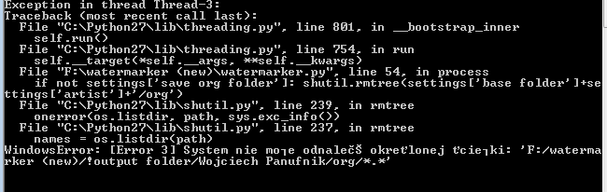
ENGLISH TRANSLATION:
Window Error: System can't find a specified path: 'F:/Watermarker (new)/!output folder/…"
This was due to the sessions ‘feature’ that I implemented for the session stuff, which I did not pick up later, sorry I have fixed this. As below I have removed the feature entirely as you have asked for.
Just a note, the org folder is always created as it the one used to process the other folders, then at then end it is then deleted if the chekcbox is not selected.

Processing crashed even in the folder there was only a single file to process.

e) KEY PROBLEM: during processing 27 files the program processes 21 of them in demo folder (other folders return 27 files processed). This finishes with such error:

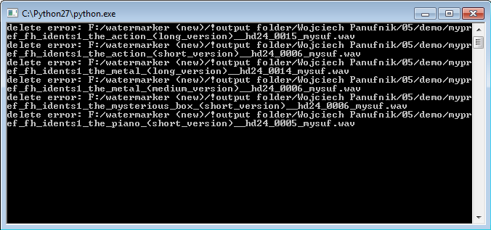
After much testing I discovered that sox was not mixing these files with the crated wfile, and that is the reason they where not being deleted after supposedly being mixed. So why where they not being mixed with a wfile? Because these 6 files are a different frequency to the wfiles.
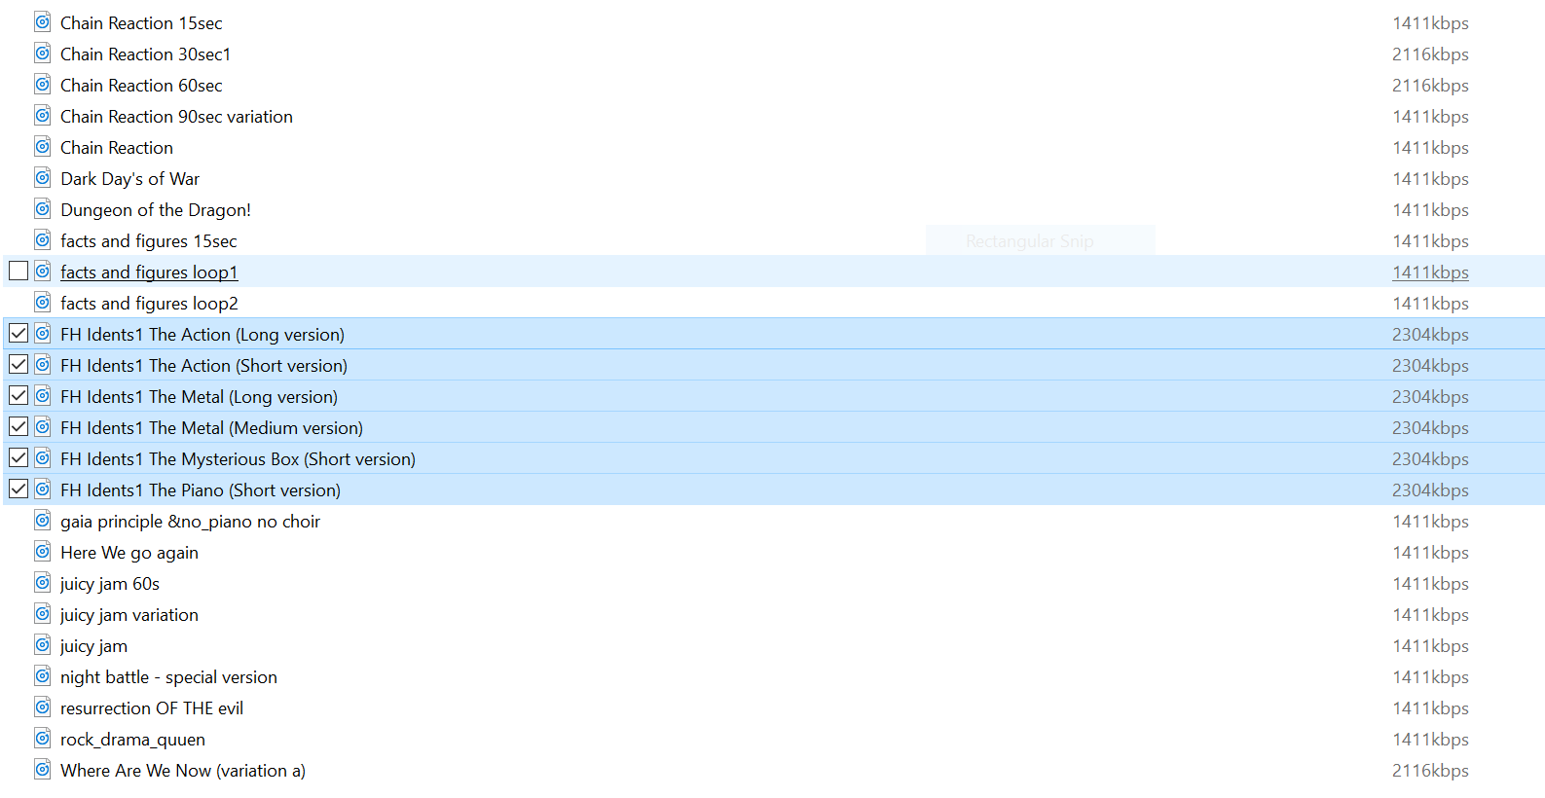
As you can see they are in fact 48Kz samples, not 44,100 like the other samples.
What would you like to do here?

f) KEY PROBLEM: volume adjustements in the mixing process are not done properly for files which have very long and very silent intro in the begining and loud main part.

The example of such file is "Rock Drama Queen.wav". After mixing original file (from I-Files folder) we get output like this:

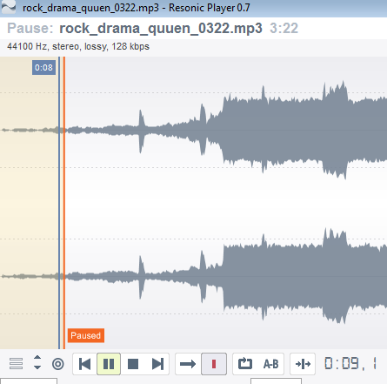
What you see here is w-file added in 0:08. It's correctly mixed as you don't see any high peaks outstanding under the entire waver form. It's correct. The problem is with the next w-file chunk which is at 0:19 (attached same waveform with marker set):

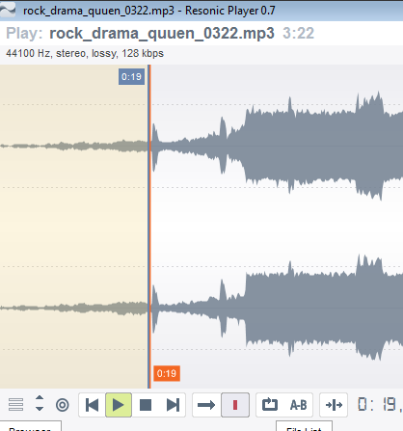
As you can see looking at those pictures (and hear!) the volume of this i-file was only very, very slightly adjusted, or nearly not at all, looking from 0:16 - 0:19 and further. So, why first w-file was mixed properly and second is mixed in so loud that it peak is 3 times bigger than the waveform (and audibly far too loud)?
Audio mixing works as follows: two wav audio tracks are simply added together. Every and all audio mixers from sound editing to daw studios use exactly this simply algorithm. In your case, because the underlying sample is picked up as louder, therefor the mixing program uses a louder version of the wfile, which when put together will create an even louder output. This is the same principle that you use when you do your mixing, at the end of your chain you use dynamic compression for this season. I asked you before if we need to implement dynamic compression and you said no. Also there is no eq involved, so this really is not down to subjective human interpretation of loudness but using the most advanced loudness meters know to man.

What is interesting when I added 32 seconds of total silence to the beginig of this i-file (rock drama queen.wav) to test if function 'trim beg silence' works (and unfortunatelly it doesn't work) I found very strange mixing of w-files which are mixed in this 32 seconds -INF dB silence part (why? I think watermarking shouldn't occure if volume is = 0) and what's more interesing, please look at it:
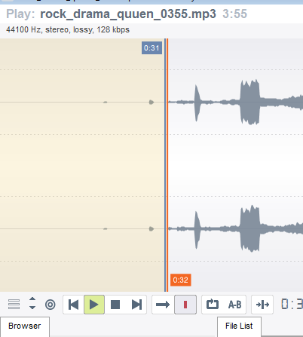
What you see is 32 seconds silend in rock_drama_queen at the beginign. Now this is demo file after processing. First w-file (at 0:08) was not added. Second peak is the 2nd w-file added in 0:19 which is audiable, then the 3rd one is just before 0:31 and it's louder then previous! It clearly shows this proces is not working properly. Because I-file's volume was not changed from 0:00 to 0:31 and this volume is -INF dB (total silence). And the program makes w-files are mixed in are are getting louder while i-file volume doesn't change! This is kind of core functionality problem.

I am attaching the file with silence at the beginning to process and test to see the same as I described above: rock_drama_queen.zip.

I have added debug logging code to see what each subsection is doing of the volumes for each wfile:

03:55 minutes
(120, 8.0, ((w03, 0), (w04, 8), (w02, 8), (w02, 8), (w02, 8), (w01, 0), (w05, 9), (w02, 8), (w02, 8), (w02, 8)), 9.0)

w01 = ('W01.wav', 1.113220) # clip length is 1.113220 sec
w02 = ('W02.wav', 0.847619) # clip length is 0.847619 sec
w03 = ('W03.wav', 1.834785) # clip length is 1.834785 sec
w04 = ('W04.wav', 2.339365) # clip length is 2.339365 sec
w05 = ('W05.wav', 2.520408) # clip length is 2.520408 sec

2016-08-01 23:21:55 watermark_audio_file
C:/Users/RFV/Desktop/0 income/sox audio/work/base/RFV3/full/rock_drama_quuen.wav

2016-08-01 23:21:55 watermark_audio_file
clip number: 0, offset: 8.000000, length: 1.834785, wfile_name: C:/Users/RFV/Desktop/0 income/sox audio/work/w-files splitted/W03.wav, linear_vol: 0.001494, clip1: 0

2016-08-01 23:21:55 watermark_audio_file
clip number: 1, offset: 9.834785, length: 2.339365, wfile_name: C:/Users/RFV/Desktop/0 income/sox audio/work/w-files splitted/W04.wav, linear_vol: 0.001494, clip1: 8

2016-08-01 23:21:56 watermark_audio_file
clip number: 2, offset: 20.174150, length: 0.847619, wfile_name: C:/Users/RFV/Desktop/0 income/sox audio/work/w-files splitted/W02.wav, linear_vol: 0.116776, clip1: 8

2016-08-01 23:21:56 watermark_audio_file
clip number: 3, offset: 29.021769, length: 0.847619, wfile_name: C:/Users/RFV/Desktop/0 income/sox audio/work/w-files splitted/W02.wav, linear_vol: 0.235425, clip1: 8

2016-08-01 23:21:56 watermark_audio_file
clip number: 4, offset: 37.869388, length: 0.847619, wfile_name: C:/Users/RFV/Desktop/0 income/sox audio/work/w-files splitted/W02.wav, linear_vol: 1.632496, clip1: 8

2016-08-01 23:21:57 watermark_audio_file
clip number: 5, offset: 46.717007, length: 1.113220, wfile_name: C:/Users/RFV/Desktop/0 income/sox audio/work/w-files splitted/W01.wav, linear_vol: 1.896060, clip1: 0

2016-08-01 23:21:57 watermark_audio_file
clip number: 6, offset: 47.830227, length: 2.520408, wfile_name: C:/Users/RFV/Desktop/0 income/sox audio/work/w-files splitted/W05.wav, linear_vol: 1.909203, clip1: 9

2016-08-01 23:21:58 watermark_audio_file
clip number: 7, offset: 59.350635, length: 0.847619, wfile_name: C:/Users/RFV/Desktop/0 income/sox audio/work/w-files splitted/W02.wav, linear_vol: 1.969482, clip1: 8

2016-08-01 23:21:59 watermark_audio_file
clip number: 8, offset: 68.198254, length: 0.847619, wfile_name: C:/Users/RFV/Desktop/0 income/sox audio/work/w-files splitted/W02.wav, linear_vol: 2.057558, clip1: 8

2016-08-01 23:21:59 watermark_audio_file
clip number: 9, offset: 77.045873, length: 0.847619, wfile_name: C:/Users/RFV/Desktop/0 income/sox audio/work/w-files splitted/W02.wav, linear_vol: 2.059928, clip1: 8

2016-08-01 23:22:00 watermark_audio_file
clip number: 10, offset: 85.893492, length: 1.834785, wfile_name: C:/Users/RFV/Desktop/0 income/sox audio/work/w-files splitted/W03.wav, linear_vol: 1.999181, clip1: 0

2016-08-01 23:22:01 watermark_audio_file
clip number: 11, offset: 87.728277, length: 2.339365, wfile_name: C:/Users/RFV/Desktop/0 income/sox audio/work/w-files splitted/W04.wav, linear_vol: 1.962691, clip1: 8

2016-08-01 23:22:02 watermark_audio_file
clip number: 12, offset: 98.067642, length: 0.847619, wfile_name: C:/Users/RFV/Desktop/0 income/sox audio/work/w-files splitted/W02.wav, linear_vol: 1.763405, clip1: 8

2016-08-01 23:22:02 watermark_audio_file
clip number: 13, offset: 106.915261, length: 0.847619, wfile_name: C:/Users/RFV/Desktop/0 income/sox audio/work/w-files splitted/W02.wav, linear_vol: 1.645705, clip1: 8

2016-08-01 23:22:03 watermark_audio_file
clip number: 14, offset: 115.762880, length: 0.847619, wfile_name: C:/Users/RFV/Desktop/0 income/sox audio/work/w-files splitted/W02.wav, linear_vol: 1.597173, clip1: 8

2016-08-01 23:22:04 watermark_audio_file
clip number: 15, offset: 124.610499, length: 1.113220, wfile_name: C:/Users/RFV/Desktop/0 income/sox audio/work/w-files splitted/W01.wav, linear_vol: 1.525289, clip1: 0

2016-08-01 23:22:05 watermark_audio_file
clip number: 16, offset: 125.723719, length: 2.520408, wfile_name: C:/Users/RFV/Desktop/0 income/sox audio/work/w-files splitted/W05.wav, linear_vol: 1.516534, clip1: 9

2016-08-01 23:22:06 watermark_audio_file
clip number: 17, offset: 137.244127, length: 0.847619, wfile_name: C:/Users/RFV/Desktop/0 income/sox audio/work/w-files splitted/W02.wav, linear_vol: 1.389479, clip1: 8

2016-08-01 23:22:06 watermark_audio_file
clip number: 18, offset: 146.091746, length: 0.847619, wfile_name: C:/Users/RFV/Desktop/0 income/sox audio/work/w-files splitted/W02.wav, linear_vol: 1.261398, clip1: 8

2016-08-01 23:22:07 watermark_audio_file
clip number: 19, offset: 154.939365, length: 0.847619, wfile_name: C:/Users/RFV/Desktop/0 income/sox audio/work/w-files splitted/W02.wav, linear_vol: 1.047978, clip1: 8

2016-08-01 23:22:07 watermark_audio_file
clip number: 20, offset: 163.786984, length: 1.834785, wfile_name: C:/Users/RFV/Desktop/0 income/sox audio/work/w-files splitted/W03.wav, linear_vol: 0.780462, clip1: 0

2016-08-01 23:22:08 watermark_audio_file
clip number: 21, offset: 165.621769, length: 2.339365, wfile_name: C:/Users/RFV/Desktop/0 income/sox audio/work/w-files splitted/W04.wav, linear_vol: 0.788591, clip1: 8

2016-08-01 23:22:08 watermark_audio_file
clip number: 22, offset: 175.961134, length: 0.847619, wfile_name: C:/Users/RFV/Desktop/0 income/sox audio/work/w-files splitted/W02.wav, linear_vol: 0.830524, clip1: 8

2016-08-01 23:22:09 watermark_audio_file
clip number: 23, offset: 184.808753, length: 0.847619, wfile_name: C:/Users/RFV/Desktop/0 income/sox audio/work/w-files splitted/W02.wav, linear_vol: 0.854775, clip1: 8

2016-08-01 23:22:09 watermark_audio_file
clip number: 24, offset: 193.656372, length: 0.847619, wfile_name: C:/Users/RFV/Desktop/0 income/sox audio/work/w-files splitted/W02.wav, linear_vol: 0.898156, clip1: 8

2016-08-01 23:22:09 watermark_audio_file
clip number: 25, offset: 202.503991, length: 1.113220, wfile_name: C:/Users/RFV/Desktop/0 income/sox audio/work/w-files splitted/W01.wav, linear_vol: 0.848891, clip1: 0

2016-08-01 23:22:10 watermark_audio_file
clip number: 26, offset: 203.617211, length: 2.520408, wfile_name: C:/Users/RFV/Desktop/0 income/sox audio/work/w-files splitted/W05.wav, linear_vol: 0.860700, clip1: 9

2016-08-01 23:22:10 watermark_audio_file
clip number: 27, offset: 215.137619, length: 0.847619, wfile_name: C:/Users/RFV/Desktop/0 income/sox audio/work/w-files splitted/W02.wav, linear_vol: 0.005033, clip1: 8

2016-08-01 23:22:10 watermark_audio_file
clip number: 28, offset: 223.985238, length: 0.847619, wfile_name: C:/Users/RFV/Desktop/0 income/sox audio/work/w-files splitted/W02.wav, linear_vol: 0.001494, clip1: 8

The code is working correctly as it follows the partern for files larger then 120 seconds [(120, 8.0, ((w03, 0), (w04, 8), (w02, 8), (w02, 8), (w02, 8), (w01, 0), (w05, 9), (w02, 8), (w02, 8), (w02, 8)), 9.0)]
What is happening is that the R128 is detecting that that part of the file is as loud as it is and then the relecant wfile is placed with the relevant volume into that section. This will be:

2016-08-01 23:21:56 watermark_audio_file
clip number: 4, offset: 37.869388, length: 0.847619, wfile_name: C:/Users/RFV/Desktop/0 income/sox audio/work/w-files splitted/W02.wav, linear_vol: 1.632496, clip1: 8

The reason why the r128 is detecting it as it is is unknow to me, all I can say is that according to audio forums this is the best alogrythm know for volume detection. Again, we could try the usual RMS but this is known to be even less acurate.
At the moment the R128 detect volume between 0 and 1 and then we multiply that value by the volume setting to get the volume of the relevant wfile. What I suggest is to take the r128 value and multiply it by a power before mutliplying. This will introduce a curve meaning that lower volumes will stay low for longer and will only catch up in volume closer to full volume: ie

0 ^ 1.5 = 0
0.5 ^ 1.5 = 0.35355339059327376220042218105242
0.6 ^ 1.5 = 0.46475800154489002622151184797389
0.7 ^ 1.5 = 0.58566201857385288358472041804963
0.9 ^ 1.5 = 0.85381496824546241963970125699683
1 ^ 1.5 = 1

This is my last freeby suggestion, because these things take extra time and effort, not that I wish to charge you, but I think I have done my part so far.
I have already implemented this, please try the examples now

FEEDBACK 2 : 2016/07/31
reply to RV questions from previous FEEDBACK

2. There should ba time left field shown of entire process remaining to finish (or at least % of
processing advancement). It's very important as I am processing 500 files at once and it would be long
process.
This feature required a bit of work because I had to rewrite the original encoding code to also output the
status of each step and each pass. The program will display a message for each process step and display
which file number of how many files it is busy doing.

It doesn't display any progress during processing, I don't see it. Where exactlly it is being displayed?
On the status label, right of the run button
5. In the directory FULL, FLAC, MP3 there are files with "_demo" suffix. "_demo" suffix had to be added
only to files which are in DEMO folder!

What I have done so far is add the bit_depth_suffix_string | timing_suffix_string | demo_suffix_string |
prefix_string | suffix_string to all the files in mp3, flac, full and demo (basically before processing was
done). Should all these only be done to the demo folder, or should the following bit_depth_suffix_string |
timing_suffix_string | prefix_string | suffix_string be done to all and then only demo_suffix_string be put
into demo with the others?

So just to clarify, should the naming stuff be done only to the demo folder or all? Or should it all be done
to all except for demo (which should only be in demo folder?)

No, I think it is very clearly described in the specifications:

I don't know how to put it simpler so I will give exaple of processed track called "My Song.wav" after processing the names should be like this:

demo/my_song_0116_demo.mp3
full/my_song.wav
mp3/my_song.mp3
flac/my_song.flac
org/My Song.wav

If the track bitdepth is > 16 bit (i.e. = 24 bit or 32bit) it shoud be bamed with "_hd24" suffix like this:

demo/my_song_hd24_0116_demo.mp3
full/my_song_hd24.wav
mp3/my_song_hd24.mp3
flac/my_song_hd24.flac
org/My Song.wav

NOW IT DOESN"T WORK OK, IT'S ALSO CORE FUNCTIALITY FOR ME.

Plus I don't know why you have added BITRATE CHECKBOX? I don't think it's needed. Or we can utilize it that if it's checked than "_HD24" suffix will be added to files which has > 16bit depth, ok?

I understand now, (excluding the org folder) time/length and demo only in demo folder. Bitrate in all
I have removed the bitrate checkbox

8. No preview function at all ???
The program is taking an entire list of audio files and needs to process them. What do you suggest with a
preview function? How would you like it to be implemented? Can we leave this for the next milestone as
it was not in the original specs?

OK. Move to next milestone.
Moved to next milestone

10. NO convert to 8, 16, 24 bits function
I went though the specs, I am not clear where in the process you want this to be done. Should the
original files be converted and then saved in the [full] folder OR should the filer in the [demo] folder be
converted to 8/16/24 bit?

Unnchecked by default. It's kind of "hard" convert. If checked (8 or 16 or 24bit) it makes ALL processed files except ORG folder are convereted to 8, 16 or 24 bits. It should be a selectlist rather than check box like (hard convert files to : none, 8, 16, 24 to choose from).

We can move it to another milestone though it was in specs.
Moved to next milestone

11. Regarding the specification, How do I configure:
- w-file time offset
This is another feature and I will do it for you but lets 1st make sure everything else ifs working 100%
- delete “org (dir)” (on/off) after processing
This feature is already implemented, just unclick the org folder clickbox. If not selected the org folder will
be deleted after the processing is done.

Ryan, this not new feature. I included it in the specs. And it's not like complaing about it now as it is very important feature for me. I was asking in the specs to make it configurable the offset/time delay of entire w-files chain which is mixed in. For e.g. if in the a process first w-file is mixed in 0:08 if we set the offset to 0:00 sec, the first w-file should be mixed from 0:00 sec for all files in this process. It's liek a hard offset for first w-file and all next w-file chunks being mixed after should be moved proportionaly left in the time line. If we set offset to 0:05 sec. All first w-file should be mixed in 0:05 sec and all other should be mover proportionaly (according to the normal algorigithm from mixing table for such i-file) to the right in the time line (they should be deleyed 5 seconds, all). Do you understand what I mean? It's very important feature. Optional. By default shouldn't be used.
No actually you specified the exact wfile time offsets in the specs originaly, which we then changed later (which also took a lot of extra time btw) – what you are asking for now is a feature for you to be able to change those values yourself.
You can currently find all the wfile configuration stuff in the processing.py file lines 4 – 16
Moved do next milestone

12. According the specification there is no ftp upload of entire directory processed (i.e. “wojciech
panufnik”) conatining four subdirectories (full, mp3, flac, demo) of particulair composer to the defined
directory on ftp.
Can you please explain what you mean. What needs to be done?

Just FTP upload. The button to upload tracks from processed Artist Folder to desired folder to ftp. So we need some kind of configuration of ftp (host name, local folder, user, password, etc).

I have implemented an ftp upload feature on the gui and it works from my side. I have run filezilla ftp server and tested the upload on that ftp server. Everthign that have just been processesd will be uploaded to the ftp server of your choice. The setting are also saved in the setting file_
13. There should be some kind of protection (code?) to use this tool (configurable).
What is protection code? And what do you mean with configurable? Sorry, you have to be specific
because as we have discovered before, there is a large amount of possible interpretations and I just want
to be clear?
I would like to give this tool to someone to use it (someone working for me). I have to be sure it will be a copy which runs only on his computer. Is it possible to protect is somehow for that reason. Please answert but we could move it to another milestone.
Moved to next milestone

Change regarding folder setup
To be honest I don't need this feature. In some cases it maybe helpful but for ftp upload it makes things complicated because now it couased another subfolder which can not be included in folder structure after FTP upload. After FTP upload my structure should be like that:

FtpPathSpecifiedInConfiguration/Artist Name/full
FtpPathSpecifiedInConfiguration/Artist Name/demo
FtpPathSpecifiedInConfiguration/Artist Name/org
etc.

But this feature of changed folder setup with SESSION added could be left only if we can make it optionaly switchable. By default it should be disabled. Can we do it like that?

No problem I have reverted back to without it. You just won't be able to resue the same artist folder again.

